Understanding the Principle and Techniques of Construction Project Estimating: A case of Standard Construction Firm
Wasiu Adeniran Bello
ABSTRACT:
Developing an accurate and reliable construction cost estimate requires proper understanding of the principles guiding project estimating and its techniques. The cost estimator would typically face many challenges depending on the level of understanding, available skill and experience which may lead to suboptimal estimates and or poorly defined and unrealistic assumptions. The Estimator, usually a Quantity Surveyor working in a standard construction firm should be a well-trained and experienced cost analyst who must ensure that the project has a well-defined scope, access to detailed documentation and historical data. Construction cost estimating is a foundational principle in forecasting the cost of construction project. Accurate estimates are especially critical for development projects, which have budgets and timelines. Thus, the principles of forecasting, breakdown of project to manageable size, data collection and decision making are crucial to good estimating practice. The most accurate way to estimate is usually to build a Work Breakdown Structure (WBS) supported by standard method of measurement, and to estimate all of the lowest level, individual work components. The basic principle adopted is "deal with parts first; then combine the parts to form the whole" or "analysis" and "synthesis". Attention must be given to the importance of principles of measurement in determining the cost of construction work usually consisting five discrete but related elements. The general purpose of quantification which is to present these elements jointly or separately such that their individual or combined costs can be predicted and later confirmed. The distinction between direct and indirect costs requires attention and also between variable and fixed costs while taking into consideration contingency covering possible or unforeseen occurrences. Estimators are encouraged to understand the use of the Code of Estimating Practice which provides users with recommendations for accepted good practice and sets out procedures and practice that can assist estimators in pricing the work.

INTRODUCTION
The principles of estimating are a fundamental truth or proposition that serves as the foundation for all cost estimating process or procedure for defining an established cost estimate. Understanding cost estimation requires having basic grasp of the construction process. To estimate is to produce a statement of the approximate quantity of material, time, or cost to perform construction. The purpose of the estimate is to provide information to construction decisions. Typical decisions include procurement and pricing of construction, establishing contractual amounts for payment and controlling actual quantities by project management. There’s scarce literature in studying generally accepted estimating principles against which the practice of cost estimating could be judged. This paper presents a concise explanation to estimating techniques (CoEP, 2018 and Ashworth, 2010) and develops general estimating principles from different sources that guide good estimating practice.
Construction project is the production process which starts with creation of a brief, preparation of feasibility studies; design, arranging financing and construction. It could be for residential building, institutional and commercial building, specialized industrial construction, infrastructure and heavy construction. Cost estimating is one of the key role/responsibility of a project manager. Construction cost estimating is a foundational principle in forecasting the cost of construction of a structure which generally influenced by time through the different phases of design and construction.
The estimating process lean on the construction process thus, a basic grasp of the construction process would aid the understanding of cost estimation. The different stages of construction process easily lead us to the five different levels of cost estimating accuracy pegged upon the well-defined project plans in the process using applicable estimating techniques or methods. This being the first point on the Project cycle, Cost is the very foundation of every project, as costing must be defined within the parameters of the client’s available budget using any of the available techniques. The estimating process involves applying several specific techniques and tools, in combination or separately. The most accurate way to estimate is usually to build a Work Breakdown Structure (WBS) supported by standard method of measurement thus, emphasising the importance measurement principles. This will aid construct cost estimator in identifying the pricing level in the cost analyses and the pricing level that should be applied to a proposed project following standard procedures with integrity of report.
The required principles for good estimating practice were discussed in relation to applicability of the Code of Estimating Practice (CoEP, 2018) which provides users with recommendations for accepted good practice. This is in consonance to ensuring that eexperienced cost estimators avoid pitfalls by consistently following standard procedures. This would include understanding changes in technology. The use of cost estimating applications and software is encouraged while highlighting some of the new trends design and building methods that impact cost estimating.

Construction Project Estimating
Construction as a project process typically starts with an overarching requirement which is developed through the creation of a brief, feasibility studies, design, financing and construction. The construction is the production process of putting together by forming structures such as residential building, institutional and commercial building, specialized industrial construction, infrastructure and heavy construction. Therefore, a construction project is the organised process of constructing, renovating, refurbishing a building, structure or infrastructure. Construction projects are typically one off's whereby a project team, brief, financing are put together to produce a unique design that delivers a single project. Once the project is complete/achieved the team is is disbanded and sometimes will not come to work together again. A project team management led by project manager or lead consultant normally supported by professionals such as architect, engineer, cost consultant/quantity surveyor and all other consultants are responsible for the delivery of the project. Project managers do have or hire a cost estimating professional on their team to measure and help manage the expected cost of the construction project. The accuracy of the cost estimation process determines how smoothly a project will run. Cost estimating is one of the key role/responsibility of a project manager. Construction cost estimating is a foundational principle in forecasting the cost of construction of a structure.
Depending on the type and size of a project, as well as the industry, cost estimation may fall to one individual or a team, and estimators may hold a number of different positions. For some construction projects, contractors and subcontractors prepare the cost estimates, though this is not regarded as best practice. At other times, the construction salesperson will be responsible for creating an estimate. Architectural firms may have in-house estimators, typically people who take on the estimator’s function in addition to their primary role. Increasingly, however, qualified independent estimators handle estimates against which one verifies the contractor’s estimates.
For contractors, good cost estimates win jobs. Clients usually select the most responsive or sometimes lowest bid that meets the standards and specifications they set. In a competitive bidding situation, the time and effort you spend preparing the estimate are a cost of doing business and an investment in winning the job. If urgency is a factor for a project, the speed at which you prepare a bid can also be a differentiator.

Influencing/Controlling Construction Cost Estimate
Estimates are required, to varying degrees of accuracy, at all stages of the project life cycle. Before an organisation can make an investment decision, an estimate needs to establish how much capital investment is required. Project owners also use construction cost estimation to determine a project's feasibility, scope, and the necessary budget allocations. The client holds the key to influence the construction costs of a project because any decision made at the beginning stage of a project life cycle has far greater influence than those made at later stages, as shown schematically in Figure 1. Moreover, the design and construction decisions will influence the continuing operating costs and, in many cases, the revenues over the facility lifetime. Therefore, the expertise of professionals to provide adequate planning and feasibility studies are necessary requirement of a client.
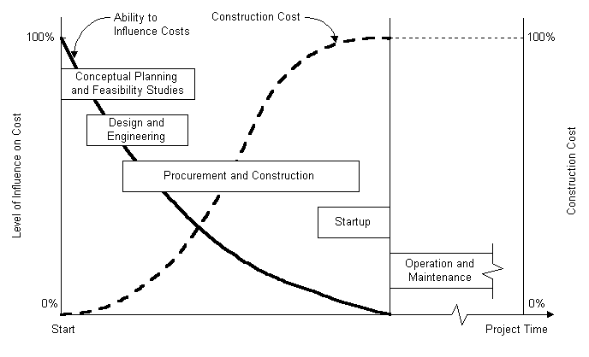
Figure 1: Ability to Influence Construction Cost Over Time (Hendrickson, 2008)
Proper construction estimation practices prevent the contractor from losing money and the client from overpaying. Good cost estimation is essential for keeping a project under budget. Many costs can appear over the life cycle of a project, and an accurate estimation method can be the difference between a successful plan and a failed one. Estimation, however, is easier said than done. Projects bring risks, and risks bring unexpected costs. Construction cost estimating is a foundational principle in forecasting the cost of construction of a structure. A good cost estimate prevents the builder from losing resources and helps the client avoid overpayment. It is a core component of project management. Creating a construction cost estimate is good practice for anyone who cares about how much their project will cost. You routinely do cost estimates for all kinds of construction projects, from building new structures to remodelling.
Accurate estimates are especially critical for development projects, which have budgets and timelines. They are also essential for large civil projects or mega-projects because of their sizable scope and the potential involvement of public money. On a mega-project, small miscalculations become magnified. In projects constructed with public funds, cost estimates increase accountability, provide transparency, and enhance trust in your ability to manage the project properly. Estimating the cost of any project with absolute precision is impossible, and projects can fail for unforeseen reasons. But a skilled estimator will account for as many factors as necessary — including such things as market conditions — to create an accurate estimate.
The accuracy of a cost estimate relies on a number of things: the quality of the project plan; the level to which the estimator defines a project; the experience and skill of the estimator; the accuracy of cost information; and the quality of any tools and procedures the estimator uses.

Overview of the Construction Estimation Process
The estimating process lean on the construction process thus, a basic grasp of the construction process would aid the understanding of cost estimation. Here are the nine basic phases of a building project although according to Royal Institute of British Architect, RIBA (2020), the way to do it is unwritten and unrecorded as the processes are generally informal as handed down from one generation of professionals to the next. The core tasks are broadly the same regardless of where in the world a building is required. It would generally include agree appointments with the professional team, develop a brief with the client, create concept designs options, Coordinate the design, prepare a planning application, apply for planning consent, develop a set of construction information, prepare a tender, obtain consents required prior to construction, award a Building Contract, construct the building, inspect the construction as it progresses, hand over the building. There are several design process maps, or plans of work, used throughout the world to guide clients through briefing, design and construction, handover and beyond. What follows is just a typical guide to the process among different others that could be available. They all have the same goals: to provide the project team with a road map for promoting consistency from one stage to the next, and to provide vital guidance to clients
1. Commissioning a Project: Commissioning is essentially a verification process that ensures that a building is designed, constructed, and delivered as a project according to requirements of the owner. It begins early in the construction process. This comes after the strategic definition phase of RIBA plan of work.
2. Briefing and Determining Requirements: The first real step in constructing a project is a pre-design phase or planning phase which includes preparation and briefing. The pre-design phase involves defining a project’s requirements: what its function(s) will be, how much it should cost, where it will be located, and any legal requirements it must comply with.
3. Concept Design and Forming a Design Team: The project owner having contracted an architect who could then select other specialized consultants to form a design team. Complex projects and projects which require meeting specific design requirements will have more specialized consultants on board to ensure the design meets requirements. The architect is generally responsible for proper coordinating of the design process, though for some projects (such as industrial construction), an engineer may be one of the people overseeing design.
4. Spatial Coordination/Designing the Structure: This step deals with the architect creating a series of designs. The architect works first with the owner to decide on the broad strokes of the design and then increasingly closely with the other members of the design team to flesh out the structure’s design in accordance with requirements. Designing thus progresses from a schematic design phase, when the architect presents a high-level design to the owner for approval, to a design development phase, when the architect works with the design consultants to decide on specifics of the construction design. The last step is the construction documents phase, i.e., creating construction drawings and detailed specifications from which the contractor will build. Estimators produce and revise cost estimates for the project as the architect fleshes out the design.
5. Bidding Based on the Scope/Technical Design: Once the construction documents are finalized, they are released to tenderers to bid on the project. Along with these bidding documents, they include instructions on how to submit bids, a sample of the contract agreement, and financial and technical requirements for contractors. These documents, which effectively define the scope of the work, are the basis on which contractors prepare their estimates.
6. Signing the Contract: Once the contractor has been selected, they execute a set of contract documents with the owners which are released to contractor that is appointed. The contractor carries out the construction phase plan and complies with planning condition related to construction. He carries out the work according to the contract agreement, and financial and technical requirements for contractors. The contract documents encompass the bidding documents, which now function as a legal contract between owner and contractor. Contracts can follow a number of models, depending on how complete the construction design is and how the owner and contractor bear risks. One of the basic models is a lump sum contract, which involves the contractor bidding a fixed sum for the total project and agreeing upon it when the project’s design is virtually complete.
7. Manufacturing/Construction: In this phase, the project team and contractor mange the construction in accordance with the construction documents. A general contractor will hire specialized subcontractors for different sets of construction tasks, such as plumbing or foundation work. Throughout the construction process, the contractor engages in careful cost control, comparing actual expenditure with forecasted expenditure at multiple points in the construction process. Cost control ensures that the contractor is actually able to turn a profit. This budget template can help you compare actual costs to estimated costs.
8. Close-Out: When the builder comes close to finishing a structure, the contractor requests the architect perform a substantial completion inspection in which the architect verifies the near-complete status of the project. At this stage, the contractor provides the architect with a document called the punch list, which lists any incomplete work or needed corrections. After the architect inspects the structure, they will add any additional incomplete items to the punch list.
9. Completion: After the contractor completes all the incomplete work detailed on the punch list (snag list), the architect performs a final inspection. If the contractor has completed the structure according to construction drawings and specifications, the architect will issue a certificate of final completion, and the contractor is entitled to receive the full payment.
An alternative method of project delivery is the design-build process, which integrates building design and building construction. Instead of separating design team and the contractor, the owner contracts with a design-build firm, which handles both functions? It can also save time and increase efficiency, and design-build processes are likely to be significantly cheaper than conventional design-bid-construct processes like the one detailed above.
Level of Estimating Accuracy in the Construction Process
The different stages of construction process can easily lead us to the five different levels of cost estimating accuracy pegged upon the well-defined project plans in the process using applicable estimating technique as relevant for different level of details for accuracy required. The American Society of Professional Estimators subdivided the system into a five-level reliable system that improves over time. The five-level system is subdivided as follows:-
- Level 1: Order of Magnitude Estimate: Made during the strategic definition stage when project design has not yet gotten under way, you only use an order of magnitude estimate to determine the overall feasibility of a construction.
- Level 2: Schematic Design Estimate: An estimate produced in line with schematic design during the briefing and concept design of RIBA plan of work.
- Level 3: Spatial Coordination/Design Development Estimate: An estimate made during the design development phase when architectural and engineering information are spatially coordinated and aligned to updated cost plan.
- Level 4: Construction Document Estimate: An estimate based on the construction drawings and specifications when technical designs are fully prepared including requirements of specialist subcontractors. This would be useful for tender.
- Level 5: Bid Estimate: An estimate prepared by the contractor, based on construction documents. This is useful for the appointment of contractor.

However, a simpler system of classifying estimates would have just three primary categories namely; design estimates, bid estimates, and control estimates. These category names reflect the way in which you use the estimates.
Design Estimates: These estimates, prepared during a project’s pre-design and design phases, start with an order of magnitude estimate, or screening estimate for feasibility then, the preliminary estimate or conceptual estimate, which is base on the schematic design. Next is detailed estimate or definitive estimate from on design development. The last of the design estimates is the tender estimate base on the construction documents.
Bid Estimates: Contractors prepare bid estimates when bidding to construct the project. Contractors will draw from a number of data points to prepare their estimates, including direct costs, supervision costs, subcontractor quotes, and quantity take-offs.
Control Estimates: Prepared after execution of the contract agreement and before commencement of construction. The control estimate functions as a baseline to control actual construction costs. The control estimate also allows contractors to plan ahead to meet upcoming costs and determine the project’s cost to completion. Contractor use the bid estimate which is usually regarded as the budget estimate for same purpose.
Estimating Techniques for Cost of construction
Primary on the minds of contractors and clients is the cost of construction. The first point on the Project cycle is ‘Cost Estimation.’ This is the very foundation of every project, as costing must be defined within the parameters of the client’s available budget using any of the available techniques. Project managers have a cost estimating or quantity surveying professional on their team for measurement and cost management of the construction project. The accuracy of the cost estimation reports is vital to clients and contractors for assessing a project’s financial risk and the long run performance of the project. Therefore, it is common practice to call on cost estimating professionals before construction starts in order to verify that targets are feasible and reflect reality.
Accurately forecasting future costs of construction is not easy; however by learning the principles and forces that make up construction cost, anyone with basic research skills can get a rough grasp on construction cost trends and plan accordingly. Ashworth (2010) listed methods normally used in cost estimating for establishing early price as depicted in Figure 2. The use of these estimating methods needs to be understood in the context of the way in which the projects are quantified rather than in terms of accuracy alone. This is because the level of information available to the quantity surveyor and the quality of pricing information largely determines the degree of accuracy of the estimate.
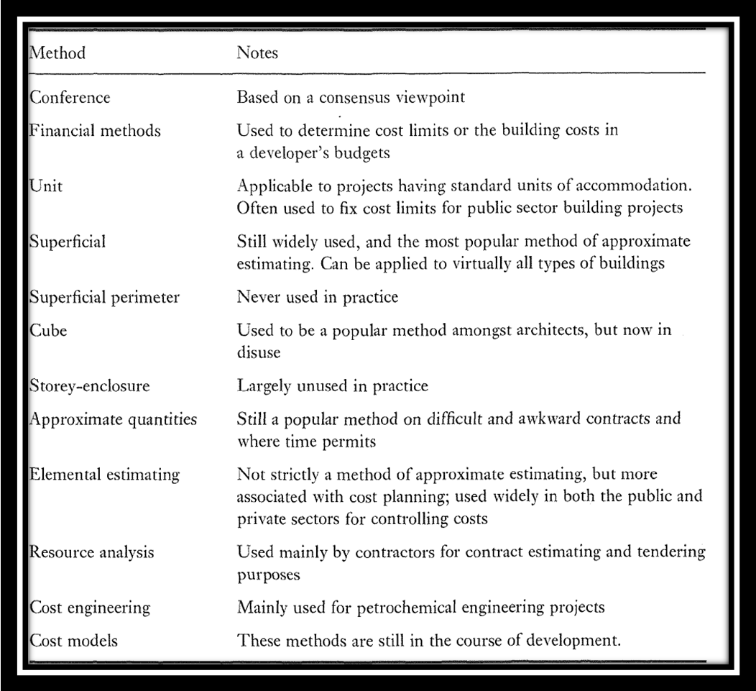

Figure 2: Methods of Pretender Estimating (Ashworth, 2010)
The above listed twelve techniques of estimating are largely unused while some are staled and unrelevant and therefore the proper assessment of the techniques for a better way to present the estimating techniques/methods. The CoEP (2018) emphasized that the degree of certainty, that is the level of detail available, will dictate which method can be used as depicted in Figure 3 whereby the CoEP (2018) has proclaim four main estimating methods: 1. Single-rate approximate estimating, 2. Multiple-rate estimating using elemental cost plans, 3. Analytical estimating, and 4. Operational estimating and thus affirm that the Order-of-estimating techniques depend on historical cost data being available from previous similar schemes.
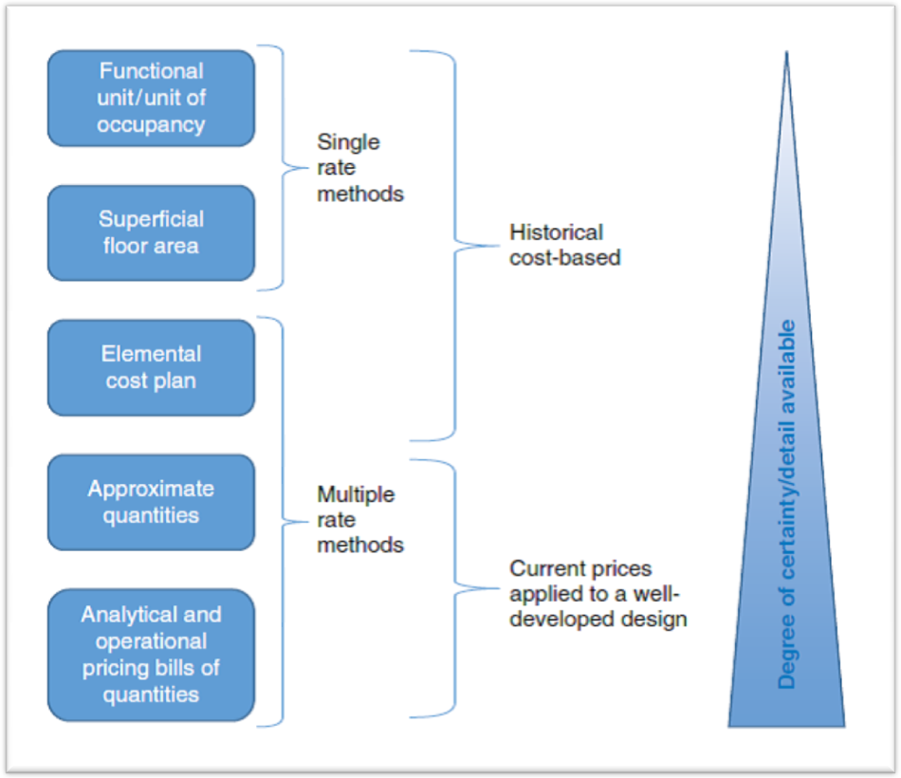
Figure 3: different Methods of Estimating (from CoEP, 2018)

Single-rate methods
These include seven of the twelve methods listed by Ashworth are used for most building projects even though some of these methods are not in use. The superficial (floor area) method is simple, using concepts widely understood and used extensively. It is used for most building projects. The building volume method takes account of storey heights but largely unused. Superficial (floor area) method uses historical data from earlier comparable schemes in terms of the cost per square metre of floor area to take account of the project complexity and type of work. Analogous estimating is in this category. Judgement, knowledge and experience are required to select the most appropriate unit price rate. This is a popular method readily understood as relatively few rules are needed to apply this technique.
The floor area of a building is defined as that measured at each floor level using the internal dimensions, without making deductions for internal walls or stairs. The gross internal superficial floor area is calculated making due allowance for plant rooms and ancillary items. As with any estimating technique, a number of adjustments are needed to take account of location, specification, degree of complexity, size, shape, ground conditions and number of storeys. In order to assess these factors, reliable historical costs are needed from a variety of buildings within each building category. A separate assessment must be made of external works, main services and drainage which can all vary substantially, depending on the nature and location of the site.

Multiple-rate methods
Elemental cost plan: This can be produced from a preliminary building design. It is based upon the functional elements of a building, for example substructure, frame and upper floors. The method depends on reliable data being available from comparable projects where the actual costs for each building element are known.
Figure 5 shows how prices from a bill of quantities for a similar office building have been set against a standard list of elements. It is shown that the breakdown of costs for a 4415m² building can be calculated simply by applying the earlier proportional cost in each element to the second building. A number of adjustments are easily made, such as the introduction of a lift and a piled foundation.
A detailed cost plan is prepared as the design develops through the design stage. Cost checks are regularly made during the design phase to check the element unit price against the budget for the element. Cost planning has evolved to become a popular method of obtaining a bid price from the contractor at the tender stage. It places more emphasis on the work of the estimator who must measure the detailed quantities in order to price the work.

Analytical/composite unit rate estimating
A large part of an estimator’s time is devoted to calculating unit rates for items in a bill of quantities. It is the First principles build up of estimates which based on the detailed resources required to perform the work. Also referred to as bottom up estimation or stick estimation, it is a prevalent method by listing every single possible cost on the job in cost estimation but also relatively cumbersome. It is an accurate estimation method but very time-consuming.. In addition to analytical unit rate pricing, the estimator will use the following techniques:
◼ Spot items
◼Operational estimating.
Spot items: These are operations which are difficult to break down into discrete items of work in a bill of quantities. For example, the demolition of small buildings or the formation of openings through walls is priced by looking at the extent of the work during a site visit. For estimating purposes, spot items may be treated in several ways:
◼ Approximate quantities can be taken off and unit rates used to calculate a lump sum estimate for the item.
◼The description within the bills can be analysed into its constituent operations and trades and an estimate of the cost made for each.
◼ When the description within the bill is analysed into constituent operations and found to have a predominant trade, then a gang or operational assessment can be made on a time, plant and material basis so that the overall cost can be calculated.
The cost of labour, plant and materials should be separated in accordance with the general principle already described for unit rates. If bill descriptions are not clear, or if further information or measurements are required, it may be necessary to revisit the site. Thus, in this analytical estimating the technique of Resource analysis estimating is established which is used mainly by contractors for contract estimating and tendering purposes as asserted by Ashworth (2010)

Operational estimating
This system is adopted when the estimator needs to consider the overall duration of an operation and its interrelationships with other trades. This is the case with civil engineering construction or the earthworks and concrete elements of a building project. In these cases, it is unrealistic to look at a single unit of work and wrong to assume that the total cost of an operation is the product of the unit rate and quantity. This could be related to Cost engineering which is mainly used for engineering projects since the primary aim of cost engineering is to achieve the ideal balance between the price, quality, and time obligations of a project. Therefore, in the interests of accurate estimating, estimators may wish to price some parcels of work as a whole package rather than as a series of separate items.

For example, a contractor may make an assessment for laying precast concrete manhole rings on the basis of the number a drainage gang can fix in 1 day. For a 2.10-m diameter manhole and 600-mm high units, the estimator might assume that 15 units can be handled, lifted into position and securely bedded in 1 day. If a project has 25 precast concrete units, an allowance of 2 days may be needed because it might be difficult to deploy the plant elsewhere for a small part of the second day. It is unlikely that a simple unit rating exercise would have included an allowance in this way for standing time. Operational estimating depends on a careful study of how a section of work will be carried out in practice. It is difficult, for example, to price the fixing of roof trusses without looking at working methods.

Cost Modelling (Also, Statistical modelling or Empirical Cost inference method)
Design cost modelling is a fundamental cost management support tool used by construction economists/quantity surveyers. This method uses statistics and regression models to determine a project's cost. The accuracy of design cost modelling is vital to the success of building developments and the viability of clients, consultants and contractors. This considers that the cost estimating model used in design phase must be in coherence with the definition report of the project. The model serves to compile the costs, direct and indirect, necessary to project completion and according to the adopted planning in order to set up the budget necessary enough to project completion. It is interesting to note that while being a student, expectations were high as to the practice of cost modeling in the industry as Oni (2000), as a final year student published article on Cost Modelling in the students’ magazine – The Construction Cost Manager. The highlight of the conclusion of the model is the emphasis on the gross floor area in determining the cost of construction projects.

Cost planning as a vehicle for monitoring cost
Clients who are interested in building development will choose to discuss their project with an architect or surveyor or with a building contractor. One of these becomes the lead consultant who is then responsible for appointing the remainder of the design and construction teams (Ashworth, 2010). Cost planning is being used effectively to evaluate at the initial stage as a technique for design decisions in order to avoid abortive plans by equating the design requirements with the funding that was available during the design stage. Increasingly, contractors are being asked to develop designs and methods which meet affordability targets. Figure 4 from the New Cost of Estimating Practice, CoED (2018) shows stages in the pre-contract phase of a construction project. The cost plan is developed as a vehicle for continuous reporting and monitoring costs as the design advances. A simple ‘outline’ cost plan can be produced at the earliest appraisal stage, and this will be expanded into a ‘first-pass’ cost plan at Stage 1 ‘Strategic brief’. The RIBA Plan of Work 2013/2020 provides a process map of the sequence of the design process with gateways that are passed as the design moves from Stage 0, strategic definition, through the design process to Stage 4, technical design (the stage before a tender is sought).
Figure 4: Cost Reporting through Stages in the pre-contract phase of a construction project. (Adapted CoEP, 2018)

An example of a simple cost plan from our case study 1 is shown in Figure 5. The standard building costs have been taken from average rates; once the budget has been established with the client, a topdown design-to-cost plan can be produced so that the design team understands the cost limit. The main building costs are presented in a design-to-cost report which can be in the form of an elemental cost plan or as a list of principal quantities and descriptions. Figure 4 is a typical design-to-cost report aimed at designers who need costs translated into simple quantities and statements for a 7- storey Commercial Office Complex with Car parks on two floors.

CASE STUDY 1
 | COST PLAN | Preliminary Estimate/m² | 367,000.00
Category | Commercial
Type | 7 Storey Office Complex
Gross Floor Area | in m² | 4,415
Unit Cost | in Naira | 1,620,305,000.00
S/No | Element | Elemental Cost | % of Cost
1 | Substructure | 156,683,493.50 | 9.67%
 |  | -
2 | Superstructure
a | Frame | 50,553,516.00 | 3.12%
b | Upper Floors | 229,435,188.00 | 14.16%
c | Roof | 65,136,261.00 | 4.02%
d | Staircases | 13,772,592.50 | 0.85%
e | External Walls | 26,410,971.50 | 1.63%
f | Windows and External Doors | 151,498,517.50 | 9.35%
g | Partitions and Internal Walls | 7,291,372.50 | 0.45%
h | Internal Doors | 4,374,823.50 | 0.27%
3 | Finishes | -
a | Wall Finishes | 67,890,779.50 | 4.19%
b | Floor Finishes | 63,677,986.50 | 3.93%
c | Ceiling Finishes | 47,150,875.50 | 2.91%
 |  | -
4 | Fittings and Furnishings | 10,531,982.50 | 0.65%
5 | Mechanical and Electrical Installation
a | Sanitary Appliances/Disposal Installation | 21,874,117.50 | 1.35%
b | Hot and Cold Water Services | 13,610,562.00 | 0.84%
c | HVAC Installation (Pipe only) | 224,412,242.50 | 13.85%
d.i | Electrical Installation | 191,682,081.50 | 11.83%
d.ii | Generator Installation |  | 3.01%
e | Lift and Conveyor Installation |  | 3.15%
f | Protective & Communication Installation | 127,680,034.00 | 7.88%
g | Special Installations/Services Equipment |  | 2.89%
h | Builder's Work
6 | External Works
7 | Preliminaries
8 | Contingencies
 | (Figures Exclude V.A.T) | 1,473,667,397.50 | 100.00%
Figure 5: Elemental Cost plan of a proposed Commercial Office Building Complex.

Importance of Measurement Principles in the Estimating Process
Measurement is based on facts, estimate is a matter of opinion and tender is a statement of policy. Estimating process involves applying several specific techniques and tools, in combination or separately. The most accurate way to estimate is usually to build a Work Breakdown Structure (WBS) supported by standard method of measurement, and to estimate all of the lowest level, individual work components. Contractors who are bidding for a job will work on one of the important document in the estimating process called the bill of quantities. The quantities calculated are measured based on fact and properly described according to standard specifications. The bill of quantities is an itemized list of the work and materials required for a construction project. The cost of construction work consists of five discrete but related elements that is easily analysed from the bills of quantities i.e. materials, labour, equipment, overhead and profit. The general purpose of quantification is to present the quantities for work section or element to provide basis for these components separately or jointly in such a way that their individual or combined costs can be predicted and later confirmed. This is a crucial step in determining the cost analysis of the work before bidding. Creating a bill of quantities is a four-step process with principles that used to be done painstakingly by hand on paper and is now usually computerised, with spreadsheets or specialized software.

- Taking-Off Quantities: Working from the construction documents, a quantity surveyor will measure the tasks and items of work in a project. This requires scaling dimensions from drawings. One will record these in standard units such as area, volume, or length. For example, you can quantify excavation in cubic meters and steel supports in linear meter. It’s important to follow one of the standard methodologies, such as the BESMM or the NRM.
- Squaring: Next, the quantity surveyor multiplies the dimensions of the component into square area and multiplies this by the number of times this work item occurs in the construction, thus getting the total dimensions, length, volume, and area as applicable.
- Abstracting: Abstracting is the collecting and ordering of the squared dimensions. Similar tasks and components are grouped together. Once you have taken off and squared all items and have obtained total dimensions, they must be merged. You make deductions for any voids or openings in the building, such as stairs.
- Billing: This last step simply involves presenting item descriptions and quantities in a structured format, the bill of quantities. You usually present these in a hierarchy for group, subgroup, and work section. (Examples include substructure, earthwork, and site clearance.)

It is important that the identified components of work can be measured, i.e. identified in physical terms. Work should always be measured in accordance with some standard method of measurement, either internally established by the individual company or organisation, or externally recommended for use throughout the industry or trade like the BESMM or NRM. There are several good reasons to adopt such a practice. Some of them are as follows: (1) the work of the estimator will be made simpler, more rapid, and probably more dependable. (2) Communications between concerned personnel will be clarified, strengthened, and hastened. (3) In the event of a dispute, there will be some precedents on which the estimator can rely.
Pricing
One of the difficulties the cost planner faces is identifying the pricing level in the existing cost analyses and the pricing level that should be applied to the proposed project. The market conditions index could be a basis for explaining the difficulty, but this does not necessarily imply or refer to specific projects in a particular area. The market conditions index will, however, provide a trend that will show whether building prices are increasing or decreasing relative to building costs. The adjustments of prices from a cost analysis or the application of new rates to approximate quantities are to a large extent a matter of personal judgment, skill and experience. This should be separated from the process of converting the contractor’s estimate into a tender bid called adjudication. Adjudication is a management activity which, particularly in a competitive tendering situation, usually involves the exercise of subtle and subjective commercial judgement in arriving at the bid amount based on policy of the organisation. Those involved in pricing a project at the tender stage are people of integrity with understanding in the following qualities that are not easily quantifiable:
◼ Systems and processes
◼ Analytical tools
◼ Data (measurement, specification, drawings, pictures and verbal)
◼ Information
◼ Technical skills
◼ Assumptions
◼ Forecasts
◼ Knowledge
◼ Experience
◼ Professional judgement
◼ Intuition.

Figure 6: Required Professional integrity for pricing/estimating
Reliable input means completed drawings, specification that clearly defines the scope and quality of the work, measured work and conditions of contract, with the duration for the activity or the project stipulated, or left to the discretion of the contractor. Estimates and bids must be accurate, reliable and correct; however, there will be margins of error when forecasts, assumptions and allowances for risk are included in the estimating. The term ‘estimate’ should be used carefully, to ensure that the recipient is clear whether the estimate constitutes a formal offer, or the estimate is an indication of likely cost. There is no rule of law that the use of the word ‘estimate’ on a document prevents it amounting to an offer. Where such a document carries standard terms and conditions, that will generally be a strong indication that the document is an offer capable of giving rise to a contract if accepted expressly or by conduct. Understanding and bringing together these factors requires skill, knowledge, experience, data, information, assumptions and feedback on past performance. The estimating process requires systems and the ability to deal with complexity. Computer-assisted estimating systems have helped and continually improve the estimating process with automated measurement, electronic tendering and the use of databases of information that can be manipulated for a particular project.

Figure 7: Item attributes of pricing construction activities
Pricing construction activities involves understanding the measured item with:
◼ The description of the activity
◼ Its context in a project (is it a single activity or part of multiple activities?)
◼ The location of the activity on the project
◼ The resources and specialist skills needed to undertake the activity
◼ The productivity rates
◼ Production methods to be used
◼ The time required for the activity
◼ The relationship and interdependence with other activities
◼ Any temporary works requirements
◼ The plant, small tools and equipment required
◼ The potential impact of the weather on the activity
◼ Quality of workmanship and materials required
◼ Wastage of materials and removal of the waste from site
◼ Delivery and storage of the materials
◼ Handling the materials to the point of use
◼ Supervision required for the activity
◼ The risk factors involved with undertaking the activity.

Understanding and bringing together these factors requires skill, knowledge, experience, data, information, assumptions and feedback on past performance. The
estimating process requires systems and the ability to deal with complexity. Computer-assisted estimating systems have helped and continually improve the estimating process with automated measurement, electronic tendering and the use of databases of information that can be manipulated for a particular project.

Rate analysis or Pricing
There are five major components of construction cost, i.e. material, labour, equipment, overhead and profit. For any particular item of work or an element of building, the total cost of a selected or a representative proportion of the total amount of work is divided by number of units of such work. This is the basic technique adopted at the unit prices of different items of work.
It can be argued that the study of pricing should precede the study of measurement, because the objective of measurement is to permit pricing to be done, and that one should therefore know how to measure it. As a matter of practical fact, the measurement and pricing processes are interdependent to such an extent that it is immaterial which is tackled first; ideally, they should be considered simultaneously. However, it is expedient to separate them for one important reason, i.e. measurements for a particular project do not change with respect to time whereas the costs associated with pricing change. If the project, for some reason, is taken up for execution, on a fairly later occasion, costs would have changed considerably and the pricing part alone, but not the measurements part of the estimate, needs to be revised. Measurement is a relatively simple exercise - as compared to pricing. While measurement is almost totally based on almost frozen drawings and specifications (fact), pricing involves consideration of large number of parameters (opinion). Measurement remain constant for a given project but pricing (especially, relating to labour and equipment) can vary from place to place and from time to time.

Basic Principles
In both the processes of measurement and pricing, the basic principle adopted is "deal with parts first; then combine the parts to form the whole" or "analysis" and "synthesis". Analysis is the separation of a thing into its constituent elements, and synthesis is the combination of such elements into a composite whole. In the analytical process, the building project requirements are divided into units of work, which are the various trade sections or distinct disciplines of work to be done; these units are further subdivided into items of work, which are the smallest individual portions of the various types of work that can be readily classified, measured, priced, and accounted for. In the synthetic process, predictions in the form of prices are made about productieity and costs of materials, labour, and machines : these prices are then applied to the measured quantities of work to produce the anticipated total cost of the project.

Principles – GENERAL ESTIMATING PRINCIPLES
The process of project cost estimation is central to setting up the foundation for making key decisions, taking initiatives, budgeting activities and controlling expenditures. The required principles for good estimating practice emphasised in the Code of Estimating Practice (CoEP) which provides users with recommendations for accepted good practice. It reflects the changing practices of estimating, pricing and bidding for work in the public and private sector building and civil engineering construction works. Estimating is involved from the strategic definition stage of a project, through the design, tendering and production stage, up to completion and use. Cost Estimation in project management has been defined as the process of forecasting the cost and other resources needed to complete a project within a defined scope. Cost Estimation accounts for each element required for the project and calculate a total amount that determines a project’s budget. The principles of estimating are a fundamental truth or proposition that serves as the foundation for all cost estimating process or procedure for defining an established cost estimate. Cost forecasts and projections are used to establish a set of metrics against which project success will be measured, and to communicate work progress to the stakeholders at any given point in time. An estimate must be an accurate reflection of reality. An estimate should show only the level of detail that is relevant to decisions. Completeness requires that it include all items yet add nothing extra. Documentation must be in a form that can be understood, checked, verified, and corrected. Thereby, the following principles are required of a good construction cost estimator.

- Expert Forecasts – The C.E tries to forecast the quantity, cost and price of the resources that will be needed for the full range of the project. The accuracy of the C.E require experts knowledge as it is largely dependent on how well defined is the ‘scope’ of the project which could be multi-disciplinary team work. As we learn more detail of every aspect of the project from expert team members, we can more accurately project costs. This principle assumes skilled individuals for a interdisciplinary team should make calculations to produce cost predictions. The expert team would require the use of methodological approaches and tools to develop their forecasts.
- Reality - Anyone can come up with a set of numbers. A challenge to the estimator is to produce an estimate that is an accurate reflection of reality. This is first a question of professional experience and judgment, and secondly a matter of relevant historical data, the importance of feedback. It may be calculations based on detailed analysis of the construction process. It may be the estimator’s best guess of cost and time. Usually it is a combination of these. They may be cost data from past projects or published in estimating guides. The use of such data without knowledge of its similarity to the work at hand produces an inaccurate estimate. This approach allows the estimates to be consistent with the project scope and accurate indicators of the real expenses.
- Level of Detail - Estimating takes time, which is expensive, and one should spend it only on detail that is relevant to decisions. Relevancy is based on two criteria: (1) If a particular level of uncertainty is acceptable in making a decision, the level of detail that provides this level of uncertainty is acceptable; and (2) the effect of the level of detail on accuracy of the estimate should be reasonably uniform for all components of the estimate. At the conceptual stage of design, the owner is trying to decide whether to continue with facility procurement. When design is completed, it is important that contract prices be based on adequate estimating detail. Yet even here one should avoid needless detail.
- Completeness - Another challenge is to include all items that will be in the facility yet to add nothing extra. The estimator must have the vision to see beyond the obvious components and their primary costs of construction, primarily in preparing cost estimates prior to completion of design.
In estimating industrial work, the major items of process equipment are obvious early in the design period. Estimates must include not only costs of procuring equipment but also the cost of its installation and the cost of piping, wiring, controls, and structure to support it. In addition to the cost of performing construction, there are major costs of providing administrative and physical infrastructure for the construction process, such as permits, insurance, financing, security, transportation, accounting, purchasing, utilities, warehousing, and shops. Onto this can be added costs of delays and changes that will have occurred before the project has been completed. There may seem to be a conflict between the principles of completeness and level of detail, but there is none. By level of detail, an cost estimator describes detail only at the level appropriate to decisions; but by completeness, the engineer ensures that all costs are included.
- Decisions and data – The C.E allow for investment decisions, alternatives and budget projections right at the start of the project. It is vital therefore that the contractors and clients agree on these budgetary factors at the outset, as the decisions made upfront will be used to measure the project as it progresses. Nowadays project control software systems allow data to be collected and pretty accurately assessed.
- Documentation validation - An estimate is verifiable for business decisions thus a permanent in the construction process. It is required that such document is in a form that can be checked, understood, verified, and corrected. This requires that the source of each number be readily apparent not only to the person who prepares the estimate but also to others who follow. The expert and unbiased team should validate cost predictions. First, the project manger develops initial estimates and submits them to the team for validation. A second independent judgment will help then make the estimates more correct and capture different perspectives on the estimating process. This principle becomes more important to complex projects which require producing large estimates. Conditions that were assumed must be identified. Methods of construction, equipment spreads, and crews that were selected in the estimating process must be stated, if they are not obvious. The estimate should be organized to be followed easily. It should be in a form that can be easily duplicated. On the other hand, an estimate is a working document that can be easily updated to produce accurate realistic estimates of costs.
- Breakdown – By breaking down the project into manageable parts, which resources can be assigned and at what cost, a more accurate C.E can be obtained. Usually, the standard breakdown structures apply like the Work Breakdown Structure (WBS) and the Cost Breakdown Structure (CBS), but it depends on the scope of the project and sometimes multiple structures are implemented. This could be properly prepared following the standard method of measurement work breakdown structure The WBS and CBS provide a baseline for cost management of the project during construction and could take any of these three forms of bills of quantities; elemental, work section or work package.
- The BOE report – This is the Breakdown of Estimate report because an accurate C.E cannot be just a list of figures. Many other factors must be taken into account like assumptions, inclusions, exclusions, accuracy and whatever else is needed to fully understand the holistic project cost. the cost breakdown structure (CBS) ‘…represents the financial breakdown of a building project into cost targets for elements or work packages.
- Direct and Indirect Costs - A direct cost of an activity is physically traceable to the activity in an economic manner. A direct cost is one not counted if the activity is not performed. Indirect costs are business costs other than direct costs of construction activities; they are not physically traceable and are counted even if the activity is not performed. Panacea for claims management. Indirect costs are also known as overhead. Example is shown in claim depicted in Figure 8.
- Variable and Fixed Costs - Costs can be classified by whether they change as the volume produced changes. Volume or quantity of construction activity is measured in many ways, such as linear meters, square meters, or cubic meters produced, hours worked, units installed, and months rented. If a cost changes in proportion to a change in volume or quantity, it is variable. If a cost remains unchanged in total despite wide fluctuations in volume or quantity, it is fixed. Most activities are a mixture of variable and fixed costs. Most of general and administrative costs, such as main office rent, insurance, taxes, and depreciation; salaries of main office personnel; and ownership costs of equipment; can be considered fixed for a given time period. They are often called period costs, because they occur or expire with time. Though considered fixed over a given time period, they may change considerably from one period of time to another as the level of business changes or as equipment or real estate is bought or sold. Many project overhead costs are fixed, particularly costs of installing job-site services.
- Contingency - An estimate is a prediction—an approximation that provides information for decisions and is a surrogate or substitute for actual measurement that is not economical or possible. Though the guiding concept of an estimator is accuracy, by its nature an estimate is uncertain. A contingency is a possible or unforeseen occurrence. In estimating, the word contingency is used for two types of estimates. The first is the expected value of a possible identified event. The second type of contingency is the possible cost of unforeseen events: events that cannot be identified because the architect/engineer does not know what can happen. This second type is a true contingency and the one that needs close attention, because it is a margin for error. Uncertainty and Risk - Any type of project cost should be identified and included in an estimate considering uncertainty and risk. According to Bello (2008) construction contingency averaged 5.53% of the estimated contract sum while variation averaged 11.62%, which means 'that contingency sum is less than the total approved variation by an average of 6.09%. For this purpose an exhaustive method of assessing and re-assessing project risks and uncertainties should be employed. A kind of cost estimation software can be used to associate each cost with potential risks or uncertainties surrounding the project. This software will also allow considering risks by producing accurate contingencies in cost estimates that may be used later on for developing a risk management plan.
- Integrity - Any cost estimate is required to follow an open and transparent process which should be produced with a high standard of ethical integrity. Avoiding uncertainties associated with the estimate would not be enough but should be explained in clear express terms. This principle allows integration of stakeholders in the estimating process into a team to work as a single mechanism and uses the same sources of information in order to avoid false precision and rash decisions.

Construction costs are classified as materials, labor, and equipment. Direct materials for concrete walls include ready-mix concrete delivered to the site and placed in the forms, steel reinforcement, and marine plywood and form ties from which the forms are constructed. Direct labor includes carpenters who fabricate and erect the forms; reinforcing ironworkers who place the steel; and laborers who place concrete, strip forms, and patch the concrete surface. A concrete pump and elephant trunk brought onto the site to place concrete is a direct equipment cost, and its operator is direct labor.

Indirect costs consist of: (1) Large costs that would have occurred even if an activity had not been performed; and (2) small costs that would be direct except that assigning them to activities is not economical. The job-site superintendent and tower crane are examples of the former. The superintendent supervises the concrete activity, and the crane (and operator) lifts reinforcing steel and form panels. Both are used for the concrete-wall activity; however, both are still needed even if no walls are constructed or if the quantity of walls changes. Their costs cannot be traced directly to the concrete-wall activity, and they are considered indirect costs of concrete walls and a part of project overhead.

There are two levels of overheads or indirect. Project overhead is all costs that are economically traceable to a project but that would not have occurred had the project not been performed. The superintendent’s salary and the tower-crane rental are indirect costs of the concrete process and other construction activities. However, if the project were not performed, there would be no supervision or crane rental costs. They are therefore project overhead costs, which are direct costs of the project. The second level of overhead consists of the costs of running the construction business that are not economically traceable to its projects. These are called general overhead, general office overhead, or general and administrative costs.
Figure 8a – Direct and Indirect Cost (Compare Variable & Fixed) Application

CASE 2 – CLAIM ON A DELAYED PROJECT
Figure 8b – Direct and Indirect Cost (Compare Variable & Fixed) Application

Difference in Variable and Fixed Cost
The difference between variable and fixed costs is particularly important in determining relevant costs for changes in contract quantities. The two common types of competition are lump sum bids that give the owner fixed prices and unit price bids that give the owner sets of variable costs. However, neither accurately represents a contractor’s costs, which are a mixture of variable and fixed costs. Each type of contract allows adjustment for the differences between the contract representation and the real cost picture.
Though the lump sum contract contains no variable costs, its general conditions allow an owner to adjust quantities by change orders and make provision for changes in contract sum to recognize changes in quantities. Unit price contracts are designed to be more easily adjusted. But because the unit prices represent a mixture of fixed and variable costs, a change in quantity affects contract amount by more than the variable cost. Large quantity changes can cause major inequities for contractor or owner, and unit price contracts usually contain clauses allowing renegotiation of unit prices if there are major changes in quantities.
Figure 8c – Direct and Indirect Cost (Compare Variable & Fixed) Application

Contingency
The most worrisome thing in construction project cost estimating is the occurrence of the unanticipated and unforeseen events/occurrences. The possibility of unanticipated events flies in the face of the knowledge that is the cornerstone of professional practice and control. The unanticipated may be of such a magnitude and consequence that it overwhelms ones carefully considered decisions and actions, and it controls the outcome. The worst of it, however, is not to know when one does not know, not to know when to expect error, and not to provide for the occurrence of expected error.
An estimator is strongly interested in accuracy, which demands knowledge of what will occur. Contingency represents an unknown, which seems to conflict with accurate estimating. However, when an estimator expects events to occur that cannot be identified in advance, accuracy demands they be represented in a cost estimate. An example is a project that is being planned in an area in which the estimators have little experience. They know from past projects in areas in which they had little knowledge that construction difficulties occurred that they could not identify in advance. And these unidentified events added an average of 20% to the cost of events and activities that they had identified. They therefore add 20% to their estimated costs, because not to do so would not accurately reflect their best estimate of final cost. Bello and Odusami (2009) revealed that there was a strong, positive correlation between variation and five of the variables: consultant estimate, contingency sum, planned duration, gross floor area,
Figure 8d – Direct and Indirect Cost (Compare Variable & Fixed) Application

Cost estimating Pitfalls and challenges
Developing a robust base estimate requires a well-defined scope, access to detailed documentation and historical data, and well-trained and experienced cost analysts as detailed in earlier discussions. However, cost estimating could be difficult even in ideal circumstances and requires the application of both science and judgment. The cost estimator typically faces many challenges which may lead to suboptimal estimates –having poorly defined and unrealistic assumptions, have limited or no supporting documentation, characterised by inadequate data collection and inappropriate estimating methodologies, are built from irrelevant or out of date data, provide limited or no basis or rationale for the estimate, or can show limited or no defined process for generating the estimate. Some of the challenges a cost estimator may face on projects are: not having access to historical cost databases; unreasonable program baselines; a vague or incomplete scope; unknown ground conditions or other site conditions; and uncertainty around possessions. One common source of problems is the failure to read the project documents carefully, which frequently leads to a poor understanding of the project scope and certain associated costs.
Other sources include forgetting to incorporate costs or entering costs incorrectly. These issues can be compounded by neglecting to thoroughly check the completed estimate, failure to visit the site and the inability to fully understand the site conditions. A site’s natural conditions and location can impact costs in a number of ways, and a cost estimator will develop an eye for spotting and asking about these. This makes site visits imperative. Estimators that draw from cost data repositories might fail to adjust costs based on local conditions or could make arbitrary adjustments without considering prior experience or quantitative comparisons. Either of these can throw estimates off and make it more difficult for another cost estimator to verify an estimate. Experienced cost estimators must avoid these pitfalls by consistently following standard procedures.

Cost Estimating Applications and Software
Estimating applications make cost estimates faster and easier to produce, which is crucial in a construction market that’s immensely competitive. Construction estimating software could be desktop or cloud technology designed to streamline and improve the process of establishing quantification, cost, material, and labour estimates for construction projects. They also prove to be more accurate than human estimators working on their own, as long as you use up-to-date cost data. Estimation software has become a must-have for anyone generating complex construction cost estimates. Construction estimating software is available in many varieties, ranging from simple spreadsheet templates to online collaborative software with many features that optimize much more than the estimating process.
Free cost estimating software is available, but it has limited functionality, and it’s not really suitable for anything but smaller projects. For-purchase software, which can be pricey, is a much better option for anyone dealing with complex projects because of the functionality and features it can offer. Here are a few of the benefits of for-purchase software:
- Cost-Related Inputs and Processes: Estimating software can offer access to cost databases, calculate taxes and the costs of labor and materials, allow estimators to adjust prices to local contexts, feature standard-size room lists, as well as item or activity lists, and integrate with accounting software. Some offer worksheets for specific trades and calculators for standard costs.
- Generating Estimates: Estimating software can perform measurements and take-offs, count objects, allow estimators to mark up construction drawings, and generate bills of quantities.
- Documentation: Estimating software offers templates for proposals and cover letters, generates proposals and cost reports, and maintains records of past projects.
- Other Features: Some software offers support for macros, online collaboration, and the ability to integrate with computer-aided design files.
Three functions prove to be the most critical when buying cost estimating software:
- Takeoff software - this provides for measurement from paper or electronic plans
- Built-in cost database - this provides reference cost data which may be your own or may come from a commercial source, such as RS Means
- Estimating worksheets - these are the spreadsheets where the real work takes place, supported by calculations and other features

New Aspects of Construction Cost Estimating
Construction cost estimating continues to evolve as design, building methods, and materials change. Some trends that impact cost estimating today include:
- Building Information Modeling (BIM): A BIM is a digital model of a structure and all its characteristics and dimensions. From the design to the construction, commissioning, and maintenance of a building, all participants can use the model.Advancements in automated measurement and quantification, as well as the development of BIM processes, have helped pave the way for more efficient automation of quantity surveying function. BIM is being widely adopted adopted in the construction industry and for this reason, the expectation is that quantity surveyors embrace it for the purpose of boosting the cost-effectiveness. As such, there’s an increasing demand for cost estimating to become an aspect of BIM, though this opinion has not been without challenges. The main criticism of cost estimating in BIM is that cost estimators, with some justification, have less confidence in the level of detail of BIM designs. The key values for estimating software include; Estimating quantity take-off and processes in general and its application to BIM; Examining the RICS NRM1 (New Rules of Measurement) for both cost estimating and elemental cost plans; Reviewing processes for BIM-based software tools to support NRM order of cost estimating.
- Sustainability and LEED Certification: Projects pursuing LEED certification earn points for various green building strategies across several categories based on the number of points achieved, a project earns one of four LEED rating levels: Certified, Silver, Gold or Platinum.Currently something of a hot topic in construction, LEED certification is a point system for rating buildings based on their environmental performance. The role of an estimator in projects seeking to obtain LEED certification involves both calculating the cost of scoring LEED points and communicating these to clients. These include not just direct costs (using environmentally friendly materials, for example), but also increased administrative costs for ensuring compliance with the LEED standards. Therefore, estimators in LEED projects should be involved during the construction design phase, so they can contribute information about costs associated with specific LEED points.

- Lean Construction and Cost Control: Lean construction, a fairly new approach, draws from the principles of lean management, which is the systematic effort to reduce waste without affecting productivity. Lean construction is a relationship-focused production management system that aims to eliminate waste from the entire construction process and deliver greater value to clients. Studies indicate that applying lean principles in construction projects results in significant cost savings. As such, an understanding of lean principles is a good asset for cost engineers/estimators who apply principles of value engineering to construction projects.

CONCLUSION
Understanding cost estimation requires having basic grasp of the construction process which helps Quantity Surveyors and or Estimators comprehend the application of different estimating techniques as it affects the accuracy of estimate through the stages. The principles of estimating are a fundamental truth that serves as the foundation for all cost estimating process for defining the integrity of an established cost estimate. The client holds the key to influence the construction costs of a project because any decision made at the beginning stage of a project life cycle has far greater influence than those made at later stages. Proper construction estimation practices prevent the contractor from losing money and the client from overpaying. Failing to prepare a reliable cost estimate can have disastrous results.
The CoEP (2018) has proclaim four main estimating methods; Single-rate approximate estimating, Multiple-rate estimating using elemental cost plans, Analytical estimating, and Operational estimating. These four broad techniques embrace all other known nomenclature but identified by their estimate application process through the cost plan. Cost planning is being used effectively to evaluate at the initial stage as a technique for design decisions in order to avoid abortive plans by equating the design requirements with the funding that was available during the design stage prior to detailed quantification/measurement. The importance of measurement as part of the estimating process is sometimes saliently overlooked as a separate activities whereas the most accurate way to estimate is usually to build a Work Breakdown Structure (WBS) supported by standard method of measurement, and to estimate all of the lowest level, individual work components.
As measurement determines facts to the project, its principles should not be jettisoned. Therefore a reliable estimate would depend on the expertise and integrity of the estimator as an estimate must be an accurate reflection of reality. An estimate should show only the level of detail that is relevant to decisions. It requires completeness thereby including all items yet adds nothing extra in the documentation that must be in a form that can be understood, checked, verified, and corrected. The required principles for good estimating practice should be in relation to applicability of the Code of Estimating Practice. Possessing the required principles would also mean that the estimator is roundly prepared, well organized, highly attentive to detail, commit ethically to delivering accurate estimates despite possible pressures, maintain confidentiality when communicating reports with stakeholders and well equipped with modern cost estimating applications and software including new aspects of construction estimating.

Bibliography

ASHWORTH, ALLAN (2010). Cost Studies of Buildings. Fifth Edition, Pearson Education Limited, Great Britain.

Bello and Odusami (2008). The practice of contingency allocation in construction projects In Nigeria. In : Stephen Brown (ed.), Proceedings of the COBRAConference of the Royal Institution of Chattered Surveyors Held at Dublin Institute of Technology, 4-5 September 2008.

Carr, I. Robert (1988) Cost Estimating Principles. Professor, Department of Civil and Environmental Engineering, University of Michigan, Ann Arbor, http://www.ricarr.com/Papers/Estimating%20Principles/Principles.pdf

Davel and Lottering Construction (2019) The 4 Basic Principles of Cost Estimation. https://davelandlottering.co.za/2019/12/23/the-4-basic-principles-of-cost-estimation/

Flanagan, Roger and Jewell, Carol (2018). New Code of Estimating Practice. The Chartered Institute of Building. John Wiley & Sons Ltd.

Hendrickson, Chris (2008) Project Management for Construction: Fundamental Concepts for Owners, Engineers, Architects and Builders. First Prentice Hall, ISBN 0-13-731266-0

Ikechukwu, Anyanwu. (2013). The Role of Building Construction Project Team Members In Building Projects Delivery. IOSR Journal of Business and Management. 14. 30-34. 10.9790/487X-1413034.

Oni, Opeyemi (2000). Cost Modelling. The Construction Cost Manager, The Journal of the National Association of Quantity Surveying Students, Obafemi Awolowo University Chapter Vol. 5(1)pg 18-19.

Proest (2020). Construction cost estimating: what is it & how it works. Proest, United States https://proest.com/construction/estimating/Published on June 3, 2020

Ramos, Diana (2017) Construction Cost Estimating: The Basics and Beyond. Smartsheet Smartsheet Inc. https://www.smartsheet.com/construction-cost-estimating

RIBA (2020). RIBA Plan of Work 2020 Overview. Published by RIBA, London, W1B 1AD.

Smith A.J. (1995) Adjudication and Bid Submission. In: Estimating, Tendering and Bidding for Construction. Macmillan Building and Surveying Series. Palgrave, London. https://doi.org/10.1007/978-1-349-13630-8_11
Xpera Group (2021) Elements Of Construction Cost. Xpera Group 10911 Technology Place, San Diego, CA 92127

